POSTS -->

Dr. Shelja Sen

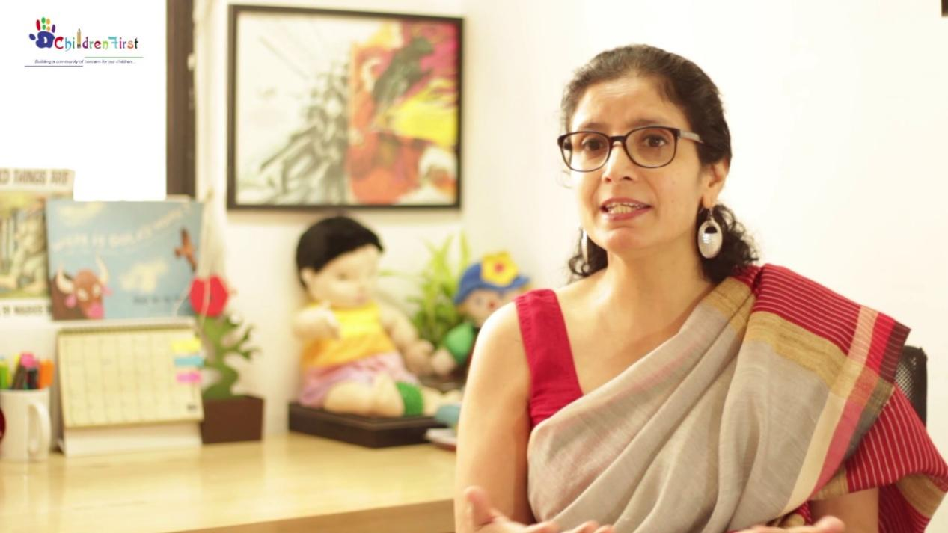

Caption - Always loved to work with kids. Yet got another chance to indulge myself in them.

@childrentrust

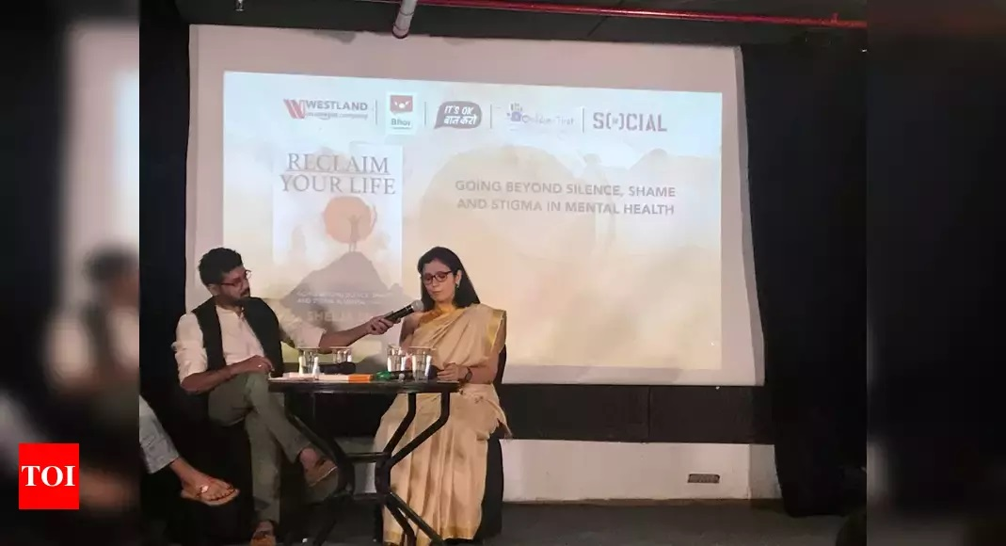

Caption - Mental Health and Art Session at Chhatrapati Shivaji Maharaj Park.

Thankyou for the cooperation everyone, it was great to talk with the students of @manthan_advertising_school

Vandana Gopikumar

[https://youtu.be/GWravWahzqs](https://youtu.be/GWravWahzqs" \t "https://www.youtube.com/embed/GWravWahzqs?autoplay=1&wmode=transparent&origin=https://_blank)

Caption - and we’re back to talk with another series of conversations to celebrate love, life, friendships and learnings.

Dr. Harish Shetty

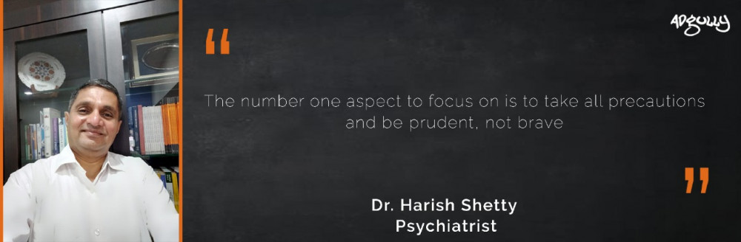

Happy to share that I have been published in the #adgully magazine.

Shri shri Ravi Shankar

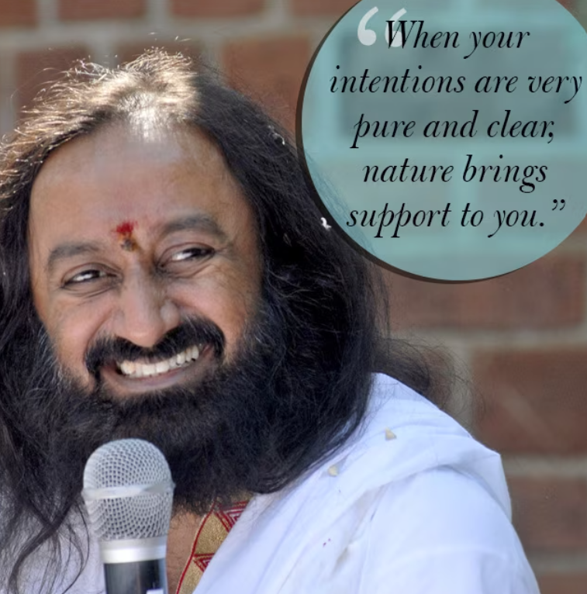

Deepika Padukone



Caption -

# Project live-love-laugh is back again to bring you an insightful yet very meaningful session on the topic '' Mindfulness for Productivity''. Join us in this session which will be addressed by Ms. Kirti Dixit Ma'am ([@kirtiphdcounselor](https://www.instagram.com/kirtiphdcounselor/)) , who is a psychologist, relationship counsellor and a PhD scholar.

Anna Chandy



Caption -

Joy of being an offering!  
  
This whole month I have dedicated to offering myself in whichever way possible. Here is my next offering as a Happiness Coach. It’s another milestone for us.  
  
Grateful & blesses to get an opportunity to release the next edition of my series of books - Battles . This one is special to me as I have collaborated with @deepikapadukone who has been an incredible support throughout.  
  
Battles in the mind is a book signifying the importance of practicing mental health regularly to stay happy, calm & relaxed.  
It includes few short techniques to practice mental health & release the negativity.  
  
The happier you are, the better you are at work!